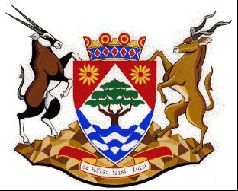
COGHSTA
Department:
Cooperative Governance, Human Settlements and Traditional Affairs
NORTHERN CAPE PROVINCE

NOTICE: TENDER AWARD: NC/16/2022

Tender Number | NC/16/2022
Description | THE APPOINTMENT OF A SERVICE PROVIDER FOR THE CONSTRUCTION OF 48 BNG HOUSES IN KAROS, LAMBRECHTSDRIFT, LEERKRANS, NTSIKELELO, ZF MGCAWU DISTRICT MUNICIPALITY
Awarded To | ICEBURG VENAQUA HOLDINGS JOINT VENTURE
AMOUNNT | R10 182 790.00
BBBEE LEVEL | LEVEL 1
POINTS SCORED | 95.98
Employer | DEPARTMENT OF CO-OPERATIVE GOVERNANCE, HUMAN SETTLEMENTS AND TRADITIONAL AFFAIRS OF THE NORTHERN CAPE (COGHSTA)
Employer | COGHSTA
Postal Address | PRIVATE BAG X5005
Town/City | KIMBERLEY
Code | 8300
Physical Address1 | Larry Moleko Louw Building
Physical Address2 | 9 CECIL SUSSMAN ROAD
Physical Address4 | 8301
Employer’s Agent: | KAREL VISAGIE
Company | COGHSTA
Postal Address | PRIVATE BAG X5005
Town/City | KIMBERLEY, 8300
Physical 1 | LARRY MOLEKO LOUW
Physical 2 | 9 CECIL SUSSMAN ROAD
Tel: | 053 807 9723
Fax: | (053) 831 4308
E-mail: | KVISAGIE@NCPG.GOV.ZA

