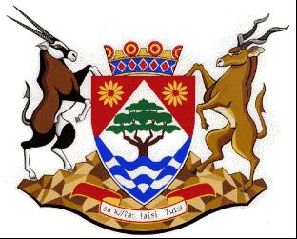
COGHSTA
Department:
Cooperative Governance, Human Settlements and Traditional Affairs
NORTHERN CAPE PROVINCE

NOTICE: TENDER AWARD: NC/11/2022

Tender Number | NC/11/2022
Description | APPOINTMENT OF A SERVICE PROVIDER / CONSORTIUM OF SERVICE PROVIDERS TO REVIEW AND TO DEVELOP FIVE (5) SEPARATE AND DISTINCT MUNICIPAL SPATIAL DEVELOPMENT FRAMEWORKS IN ORDER TO BE FULLY SPLUMA COMPLIANT FOR THE UMSOBOMVU, PHOKWANE, RENOSTERBERG, SIYANCUMA
Awarded To | TSHANI CONSULTING
AMOUNNT | R1 841 610.00
BBBEE LEVEL | LEVEL 1
POINTS SCORED | 100
Employer | DEPARTMENT OF CO-OPERATIVE GOVERNANCE, HUMAN SETTLEMENTS AND TRADITIONAL AFFAIRS OF THE NORTHERN CAPE (COGHSTA)
Employer | COGHSTA
Postal Address | PRIVATE BAG X5005
Town/City | KIMBERLEY
Code | 8300
Physical Address1 | Larry Moleko Louw Building
Physical Address2 | 9 CECIL SUSSMAN ROAD
Physical Address4 | 8301
Employer’s Agent: | KAREL VISAGIE
Company | COGHSTA
Postal Address | PRIVATE BAG X5005
Town/City | KIMBERLEY, 8300
Physical 1 | LARRY MOLEKO LOUW
Physical 2 | 9 CECIL SUSSMAN ROAD
Tel: | 053 807 9723
Fax: | (053) 831 4308
E-mail: | KVISAGIE@NCPG.GOV.ZA

