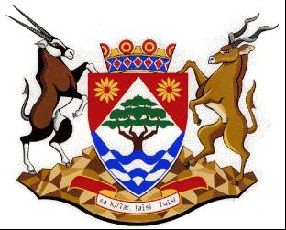
COGHSTA
Department:
Cooperative Governance, Human Settlements and Traditional Affairs
NORTHERN CAPE PROVINCE

NOTICE: TENDER AWARD: NC/15/2022

Tender Number | NC/15/2022
Description | THE APPOINTMENT OF A SERVICE PROVIDER FOR THE FORMALISATION AND PLANNING OF ADDITIONAL ERVEN ON ERF 454 MOTSWEDIMOSA AND PORTION OF ERF 2 AND 12 RITCHIE FOR THE SOL PLAATJE MUNICIPALITY NORTHERN CAPE
Awarded To | GLOBAL SOLUTIONS DEVELOPMENT
AMOUNNT | R13 371 729.52
BBBEE LEVEL | LEVEL 1
POINTS SCORED | 100
Employer | DEPARTMENT OF CO-OPERATIVE GOVERNANCE, HUMAN SETTLEMENTS AND TRADITIONAL AFFAIRS OF THE NORTHERN CAPE (COGHSTA)
Employer | COGHSTA
Postal Address | PRIVATE BAG X5005
Town/City | KIMBERLEY
Code | 8300
Physical Address1 | Larry Moleko Louw Building
Physical Address2 | 9 CECIL SUSSMAN ROAD
Physical Address4 | 8301
Employer’s Agent: | KAREL VISAGIE
Company | COGHSTA
Postal Address | PRIVATE BAG X5005
Town/City | KIMBERLEY, 8300
Physical 1 | LARRY MOLEKO LOUW
Physical 2 | 9 CECIL SUSSMAN ROAD
Tel: | 053 807 9723
Fax: | (053) 831 4308
E-mail: | KVISAGIE@NCPG.GOV.ZA

