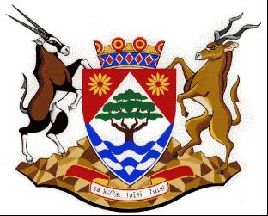
COGHSTA
Department:
Cooperative Governance, Human Settlements and Traditional Affairs
NORTHERN CAPE PROVINCE

NOTICE:

TENDER AWARD: NC/09/2021

TENDER AWARD | 18 OCTOBER 2021
Tender Number | NC/09/2021
Description | APPOINTMENT OF A SERVICE PROVIDER TO CONSTRUCT 20 BNG HOUSES IN POFADDER FOR KHAI-MA LM
Awarded To | ICEBURG VENAQUA JV
QUANTUM | R 3 378 378.00
BBBEE LEVEL | LEVEL 01
POINTS SCORED | 100
Employer | DEPARTMENT OF CO-OPERATIVE GOVERNANCE, HUMAN SETTLEMENTS AND TRADITIONAL AFFAIRS OF THE NORTHERN CAPE (COGHSTA)
Employer | COGHSTA
Postal Address | PRIVATE BAG X5005
Town/City | KIMBERLEY
Code | 8300
Physical Address1 | Larry Moleko Louw Building
Physical Address2 | 9 CECIL SUSSMAN ROAD
Physical Address4 | 8301
Employer’s Agent: Name | TEBOGO MONOAMETSI
Company | COGHSTA
Postal Address | PRIVATE BAG X5005
Town/City | KIMBERLEY, 8300
Physical 1 | LARRY MOLEKO LOUW
Physical 2 | 9 CECIL SUSSMAN ROAD
Tel: | (053) 807 9713 / 053 807 9723
Fax: | (053) 831 4308
E-mail: | TMonoametsi@ncpg.gov.za

